AIM
bTranz_Create_AR_Adjustments_Emaar
MD.120 deployment Instructions
Raya International Services

Author: Varun Sai Kumar Jonna
Creation Date: JUNE 05, 2024
Last Updated:
Version: 1.0

Title, Subject, Last Updated Date, Reference Number, and Version are marked by a Word Bookmark so that they can be easily reproduced in the header and footer of documents. When you change any of these values, be careful not to accidentally delete the bookmark. You can make bookmarks visible by selecting Tools->Options…View and checking the Bookmarks option in the Show region.

Approvals:
<Approver 1>
<Approver 2>
To add additional approval lines, press [Tab] from the last cell in the table above.
 Copy Number _____
You can delete any elements of this cover page that you do not need for your document. For example, Copy Number is only required if this is a controlled document and you need to track each copy that you distribute.

Document Control

Change Record
3
Date | Author | Version | Change Reference
 |  | Ver 1.0

Reviewers

Name | Position

Distribution

Copy No. | Name | Location
The copy numbers referenced above should be written into the Copy Number space on the cover of each distributed copy. If the document is not controlled, you can delete this table, the Note To Holders, and the Copy Number label from the cover page.

Note To Holders:
If you receive an electronic copy of this document and print it out, please write your name on the equivalent of the cover page, for document control purposes.
If you receive a hard copy of this document, please write your name on the front cover, for document control purposes.
Contents
Document Control iii
Creating Connections For Integration 1
- Creation Of FTP Adapter. 4
Creating Integration 5
Run The Integration 19
Integration Tracking 20
Open and Closed Issues for this Deliverable 23
Open Issues 23
Closed Issues 23

To update the table of contents, put the cursor anywhere in the table and press [F9]. To change the number of levels displayed, select the menu option Insert->Index and Tables, make sure the Table of Contents tab is active, and change the Number of Levels to a new value.

Create Connections for bTranz_Create_AR_Adjustments_Emaar
Creation of adapters:
- For bTranz_Create_AR_Adjustments_Emaar we are using one Adapter ftp
- To create connections, navigate to connections tab and select create option then select desired adapter as shown below.
Adapter :- it helps to store the required credentials to make a connection.

Creation Of FTP :
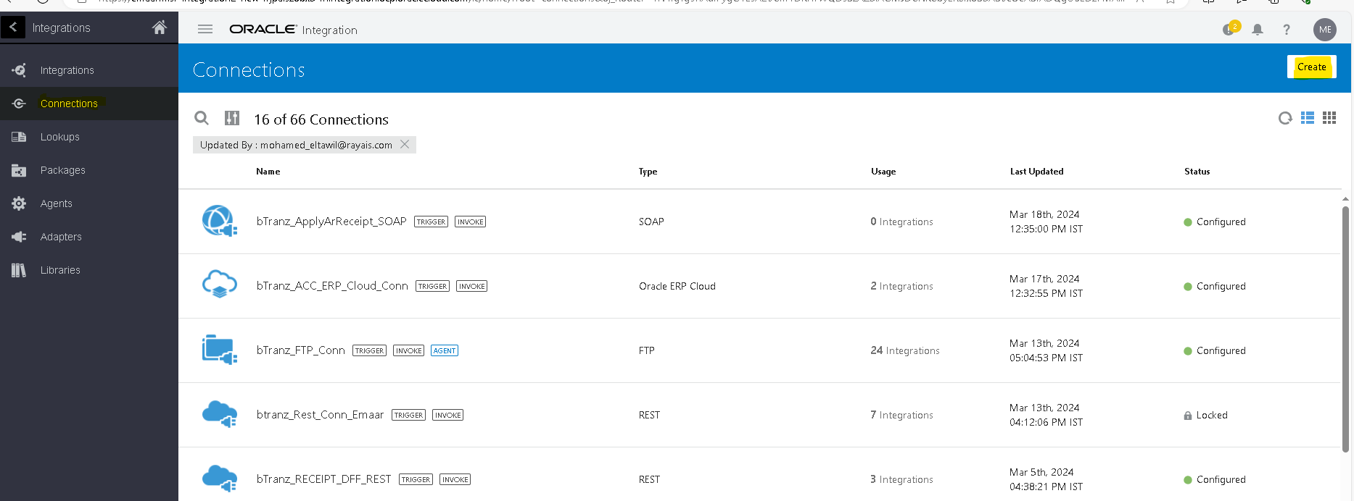
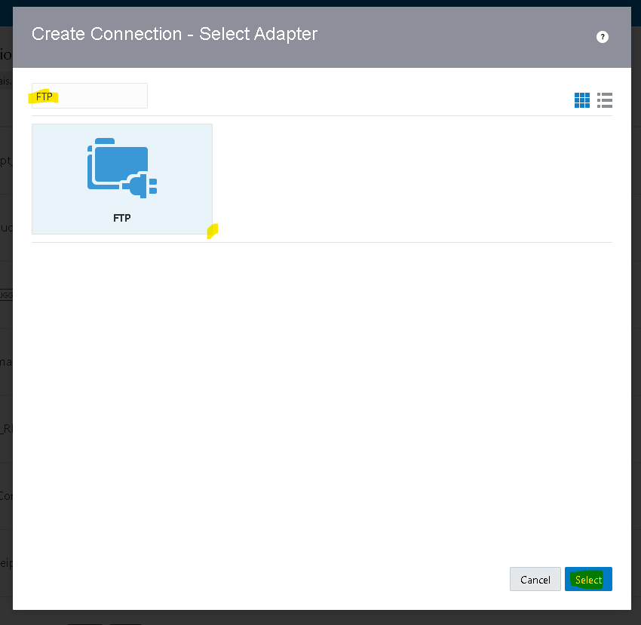
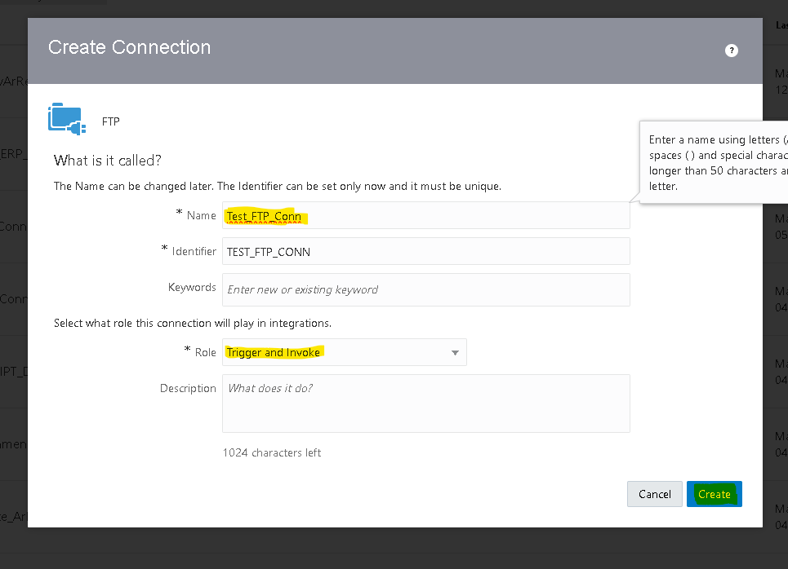

Connection Role :- a trigger means the connection where the integration receives the message. An invoke means the connection where the integration sends the message.
- Based on our requirement we choose trigger and invoke role connection.
- After clicking on create we need to pass the required Data along with the login credentials.
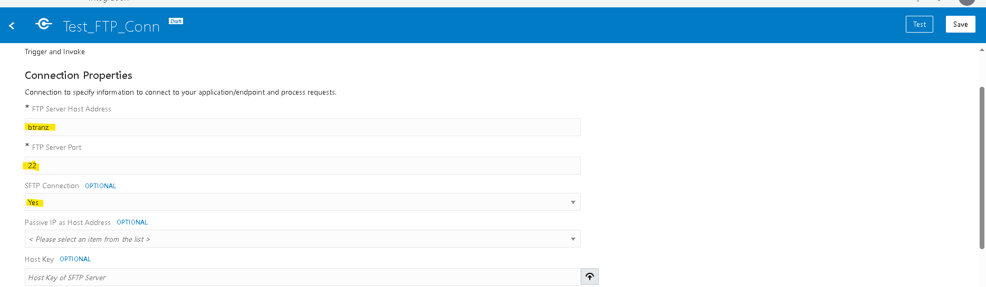
- Then click on test,popup will appear as shown above then select diagnose & test.
- After successful testing save your connection.
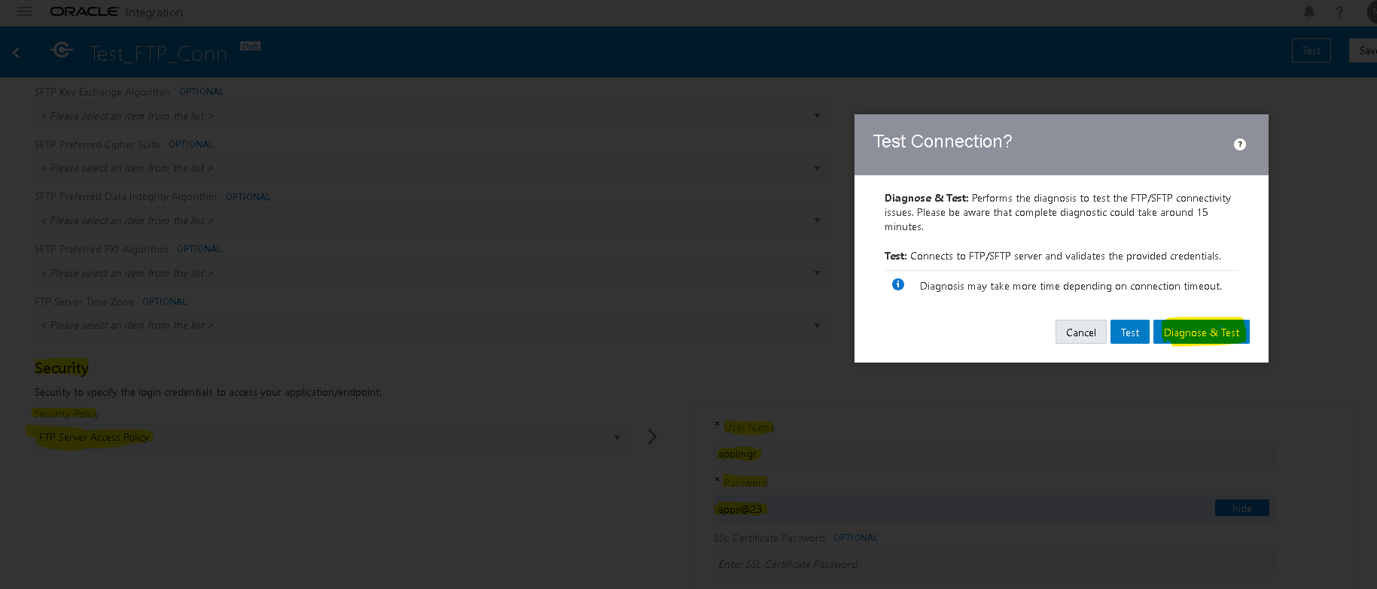

Creation Of Integration:
- Navigate to integration tab then click on create option and select scheduled orchestration.
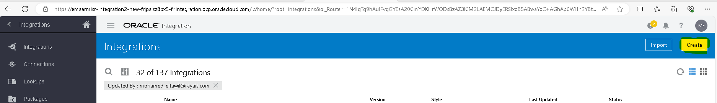
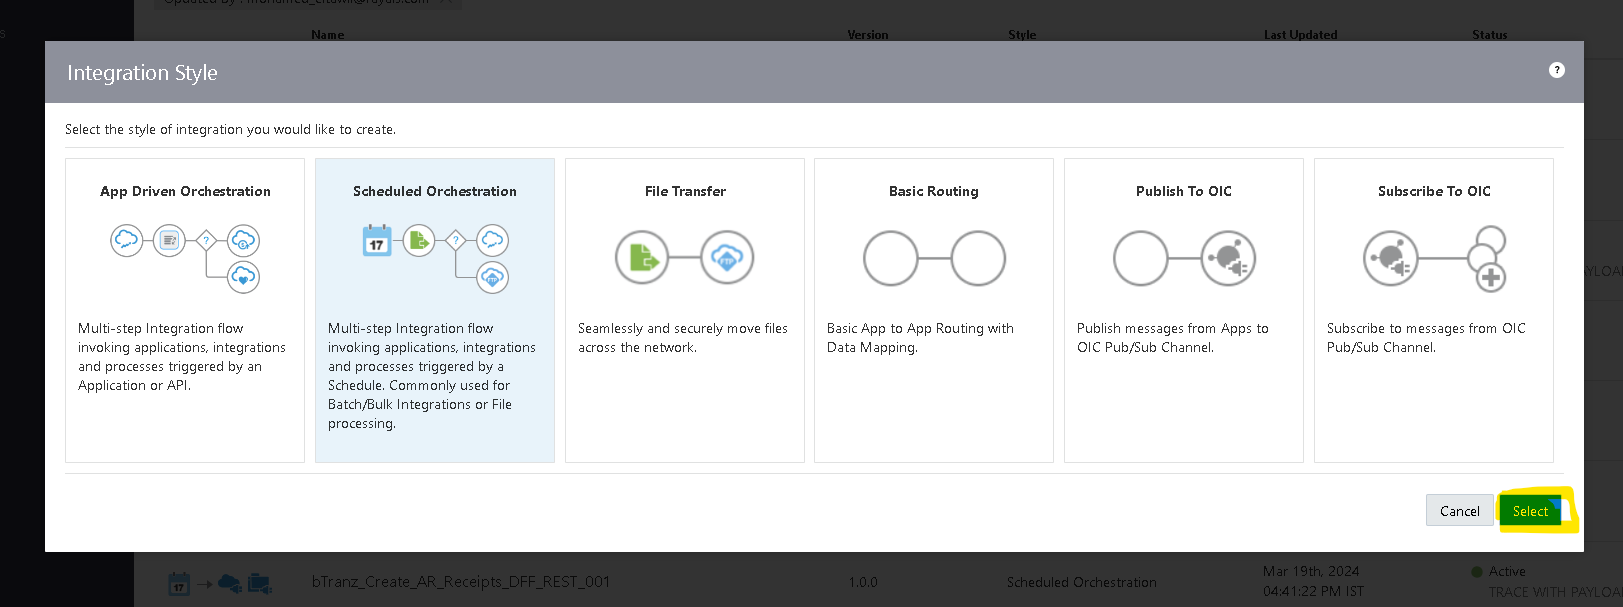

- Try to create with a unique name for identification.
- Once the integration is created select the action button on the right side of the Tab.
- Drag the Assign action and place it on plus (+) icon in the integration.
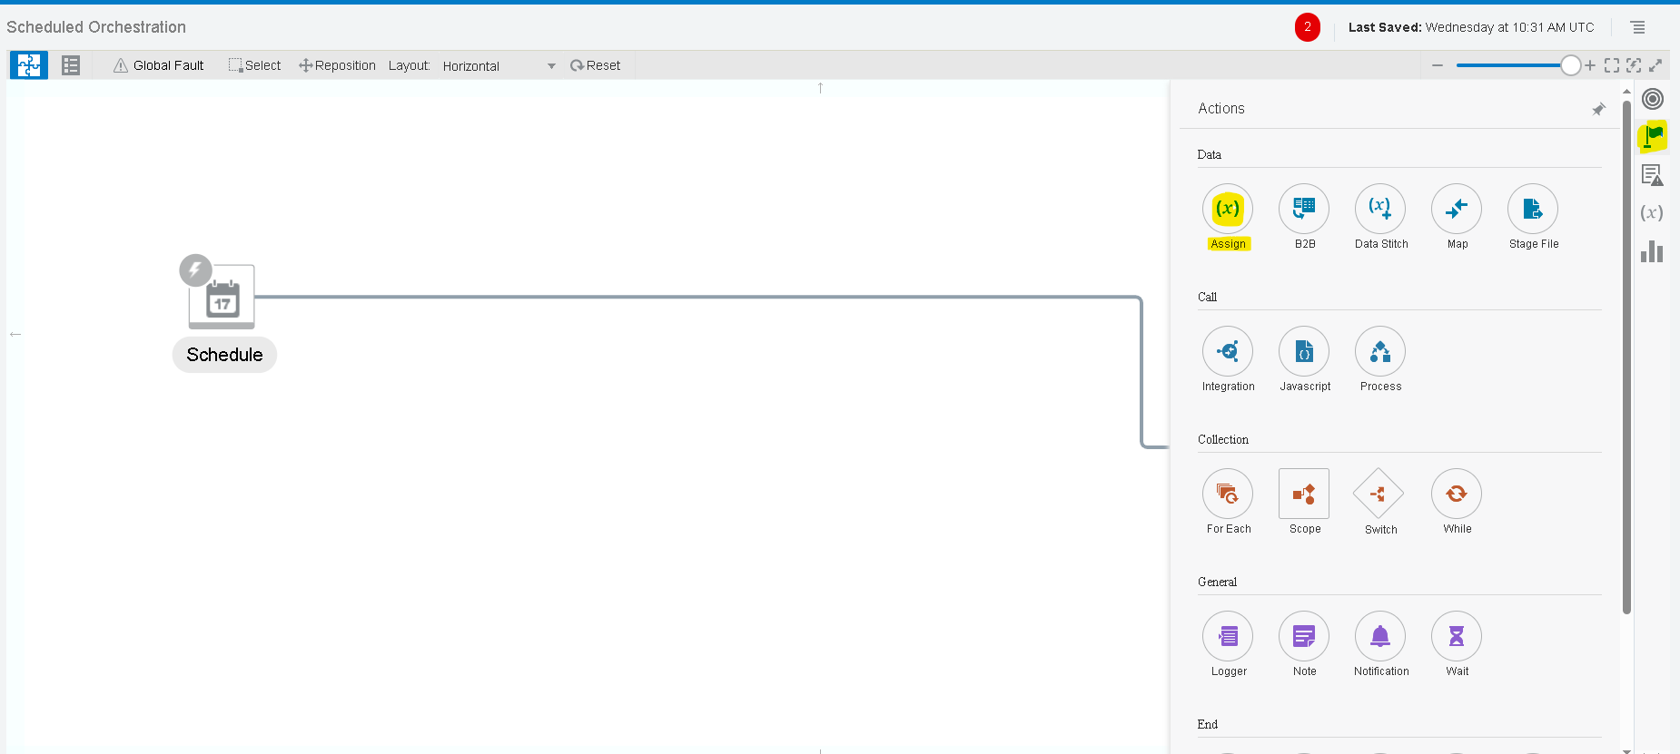
- Give a name for the assign action and click on create.
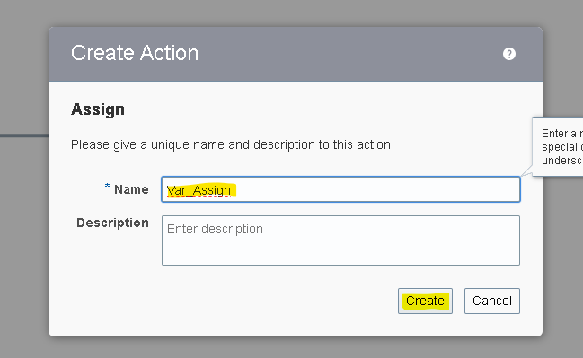
- Give the name of the variable and click on the pencil icon to assign the value for the variable.
- To add one more variable you can select plus (+) icon.
Note :- To Assign/Mention The Values We Need To Use Single Quotes .

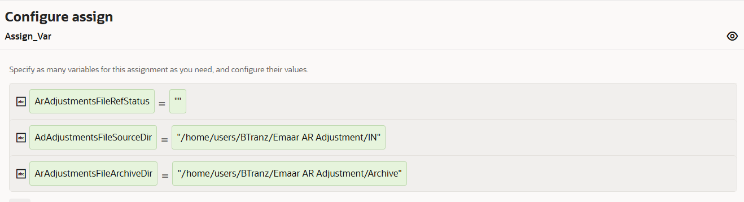
- Here we created 3 variables.

- ArAdjustmentsFileRefStatus : To store the Adjustments file status data.
- AdAdjustmentsFileSourceDir : To store the Adjustments file source directory.
- ArAdjustmentsFileArchiveDir : To store the Adjustments file archive directory.

- Select the Plus (+) Icon and select the FTP adapter which we created earlier.
- Name the ftp connection appropriate to your integration for better understanding. As we are listing the number of files in source dir, so we used the List_Files operation.

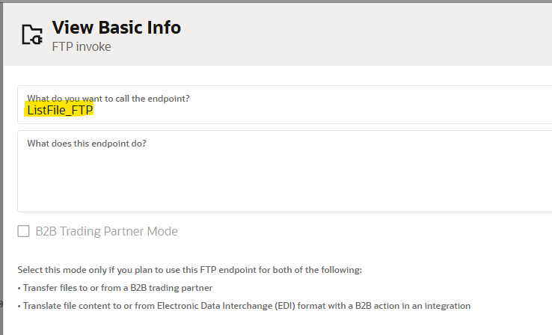
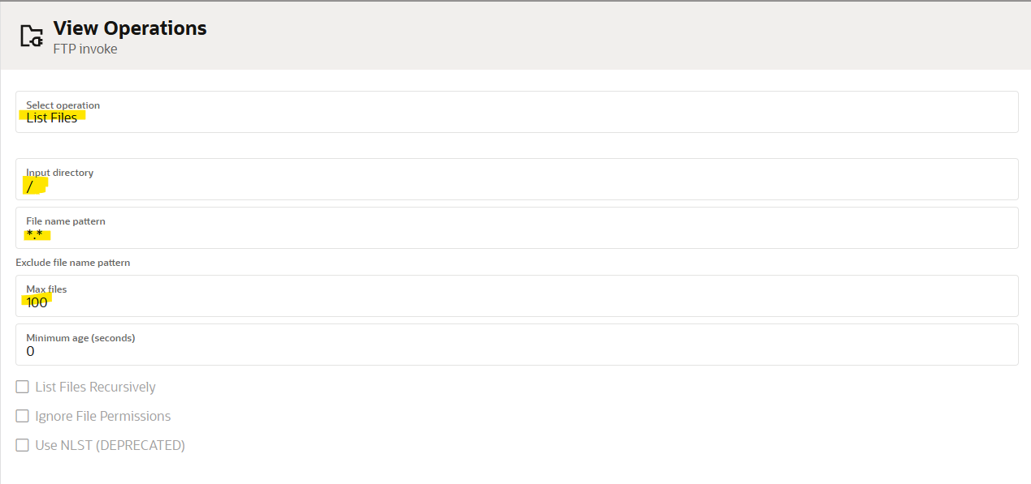
- Since we are using variables for input directory, temporarily mentioned ‘/’ and’ *’ symbols.

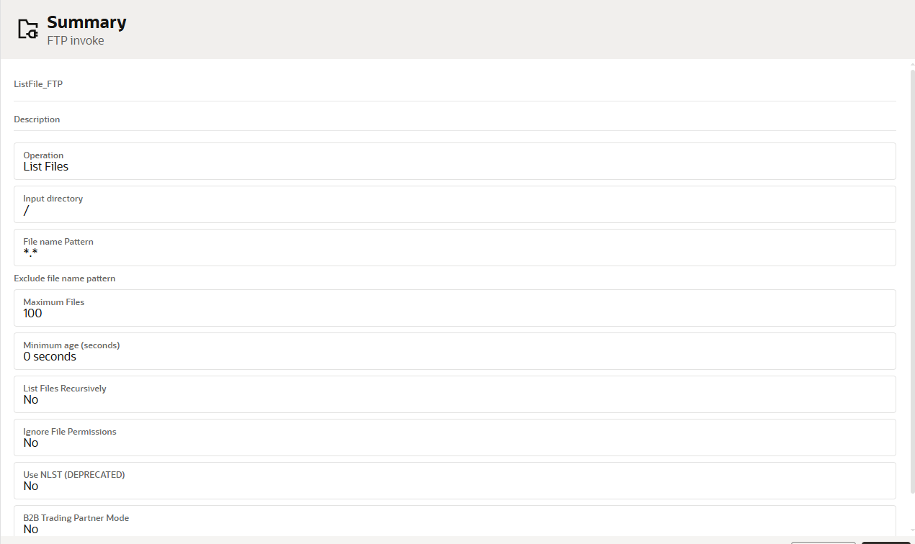
- Then it will create a mapper for ListFile_FTP.
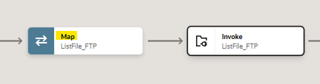
- We need to map the data for the list operation as a request.
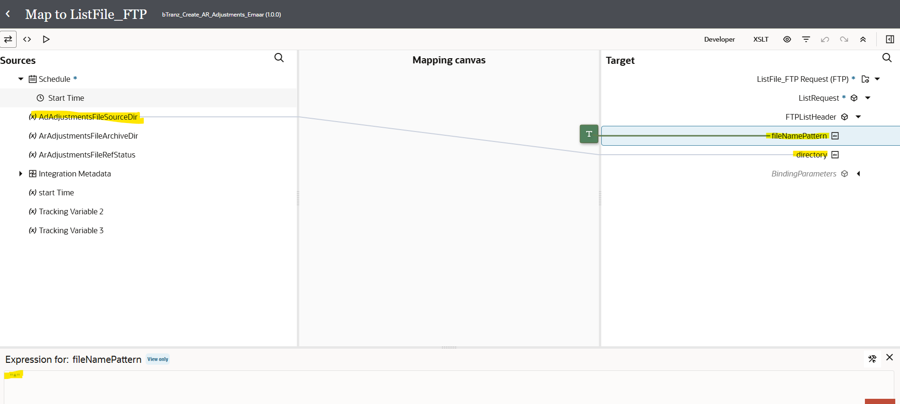
- We need to create a target node if we need to map the data manually as per our requirement.
- Here we are listing every file from the directory so we will use asterisk (*) for the FileNamePattern using single or double quotes as shown above.
- For the source file directory we will map the variable which we created before by dragging left to right and click on validate.
- Now we are using switch operation to check whether file exists or not in the listed directory.
- Once you drag the switch operation on the plus (+) icon
- We will use the response of the ListFile operation using ItemCount.
- Drag the ItemCount from the ListResponse to the switch condition.
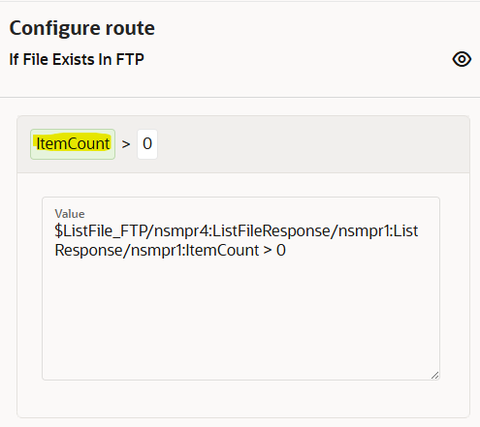

- Now we need to use ‘For Each’ action as we need to iterate each file.
- Click on plus (+) icon and search ‘For Each’ as shown below
- We will use the repeating element as the file which we got as a response from the list file operation.
- Drag the file to the repeating element and click on create.
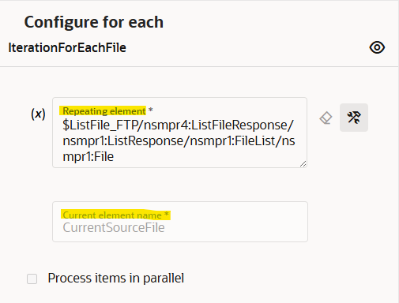

- Scope : - it is a logical container or grouping mechanism used to organize and control the flow of integration components and actions within an integration.
- We need to add a scope as we can handle any errors within scope without disturbing whole integration.

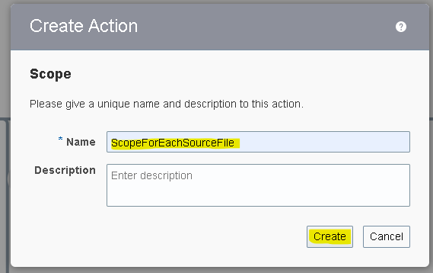
- Within the scope we are using download operation of the ftp connection.
- The download operation allows us to download the file in OIC logical directory. It is the virtual directory which can only be used within that integration.
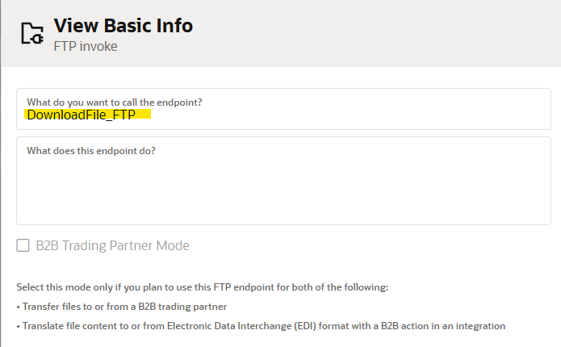

- We will map the input directory and file name later with the response of the ForEach. As of now we are assigning it.
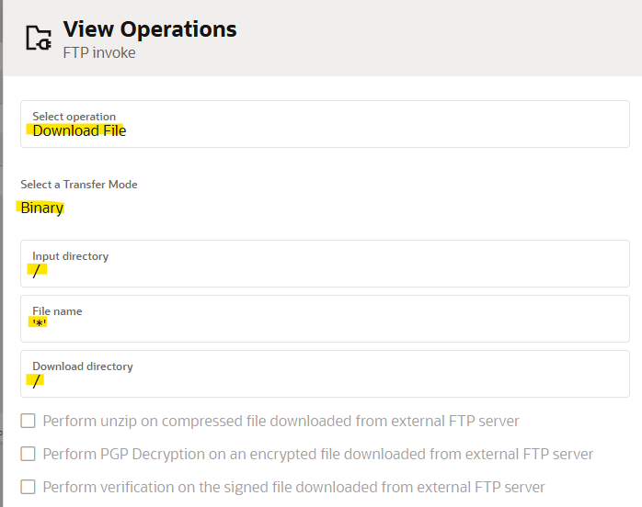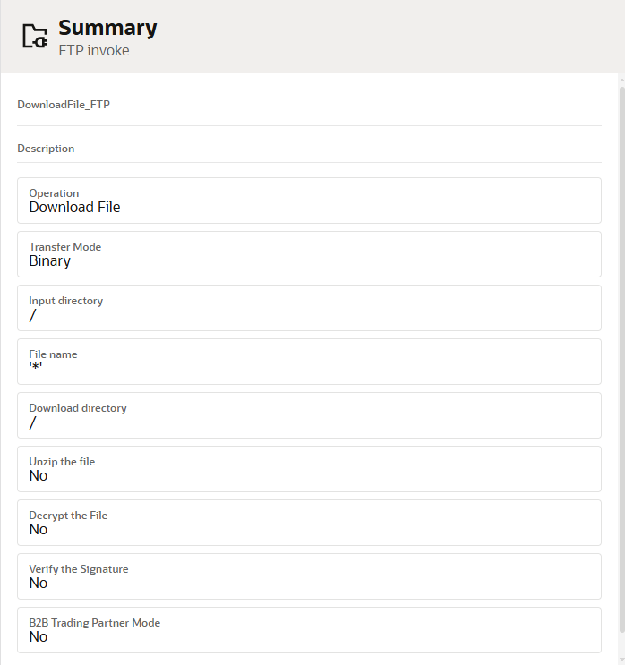
- Click on edit icon on the mapper of the download file operation and map the values.
- For the file name and the directory we are using the current source file which is the ForEach response.
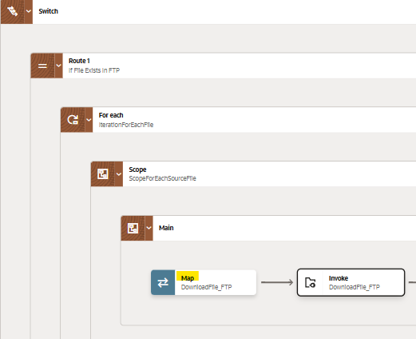
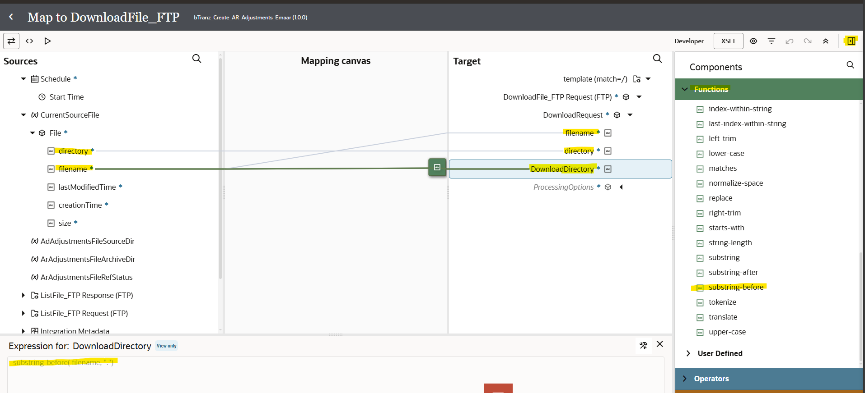
- For Directory and Filename, drag and drop the same directory and filename as shown above.
- For download directory (OIC logical directory) we are using the filename .here we are using the substring before function to remove the .extension and returns only file name.
- Drag the substring option from the toggle function option from the top right corner as shown above
- Drag the filename from the current source file and hardcode the mapper as it returns the string before the dot (.) And then validate.

- Now we will use the stage activity to read the file from the response of the Downloadfile_FTP.
- Search for ‘stage’ adapter by clicking on the plus (+) icon.
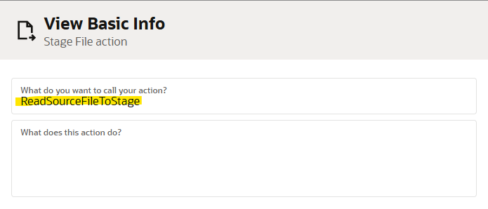
- Select the operation as ‘read File In Segments’. And configure file reference as yes.
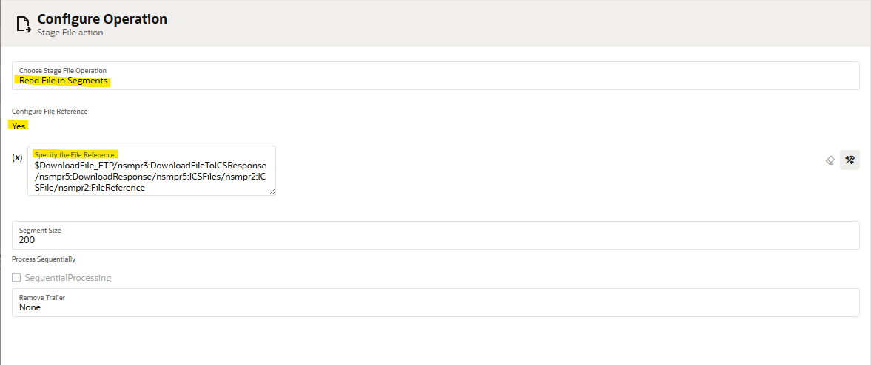
- Now we need to give the structure of the file content. As we are using the csv file select reference file from download response.
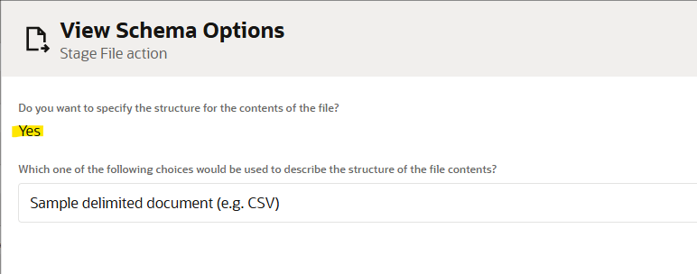
- We need to give sample structure format of the file which we will be downloaded from the ftp.
- Here choose the file from your local desktop and you can mark all as optional but at least one column should be mandatory.
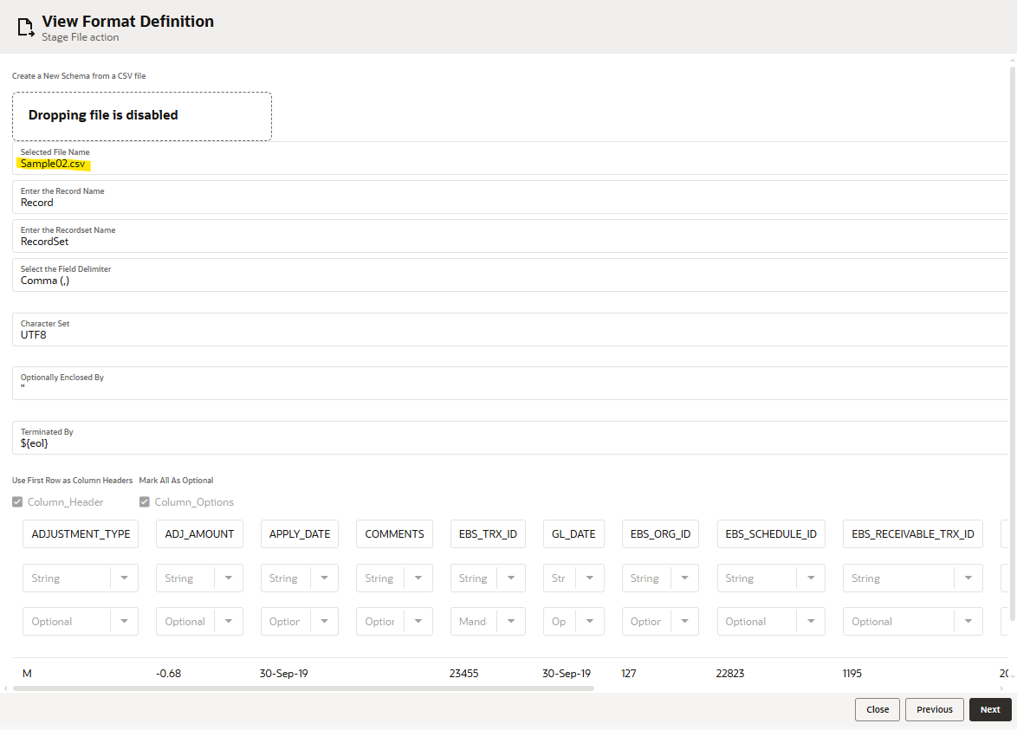
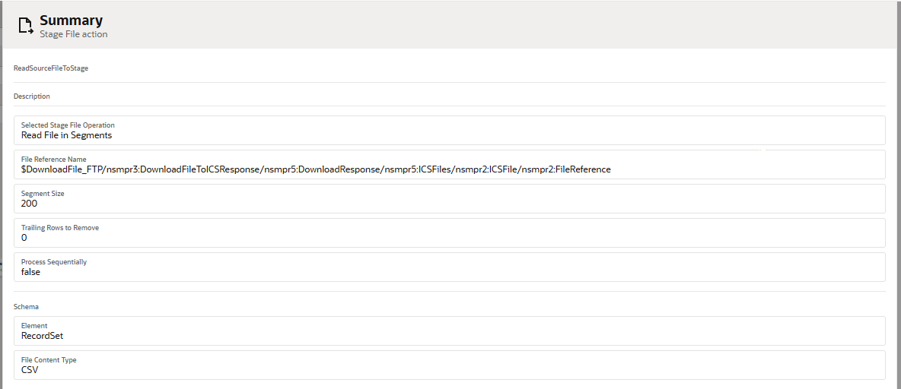

- Now give the Fault Handler for the Scope. In the Fault Handler use Notification to send message if the Scope goes into error.
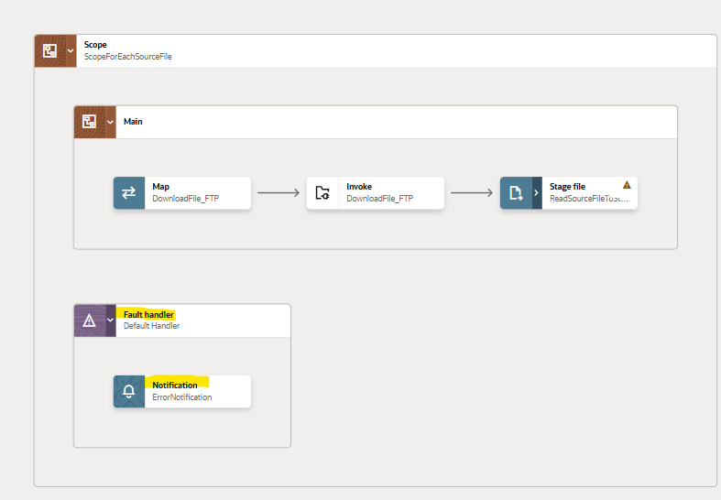

- In the Notification give the details as shown below.
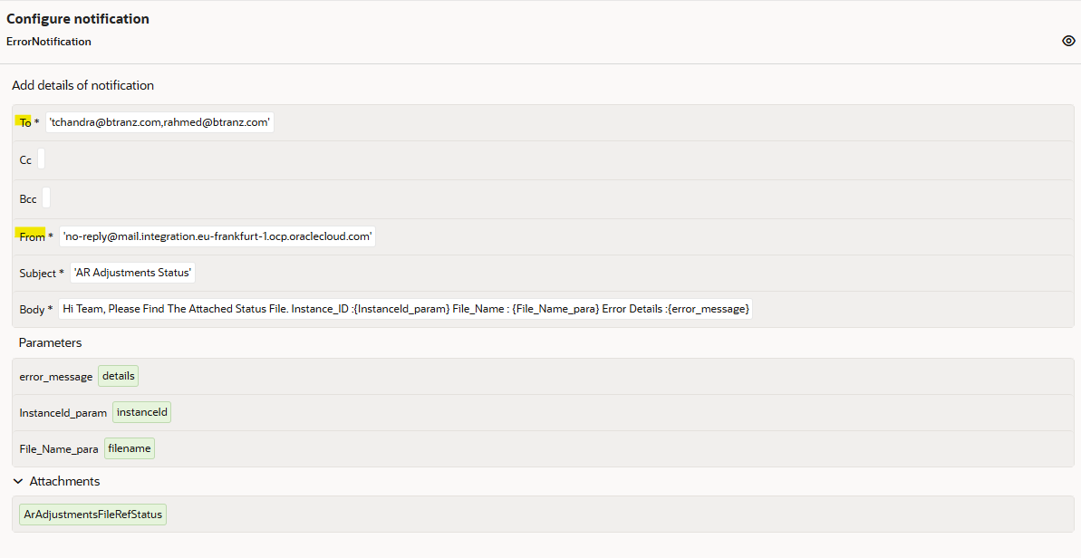

- For Parameters in the notification, take information from the input sources as shown below.
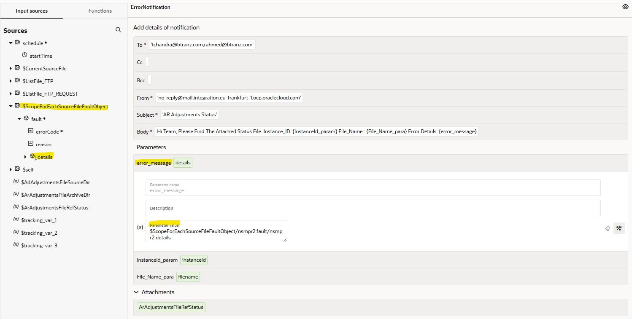
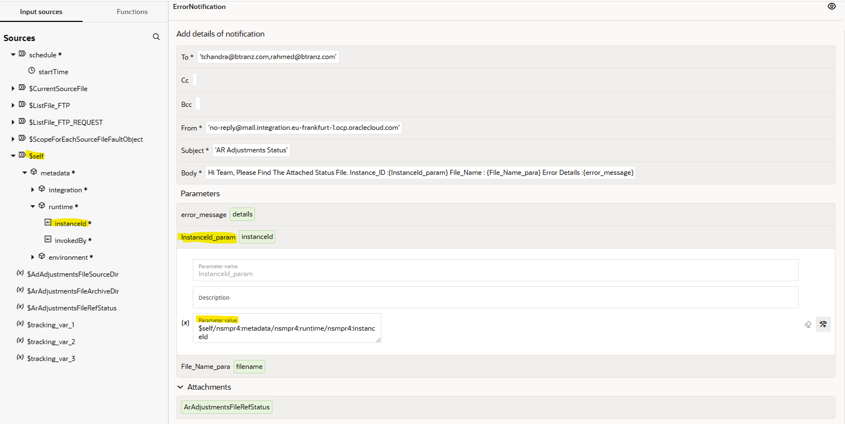

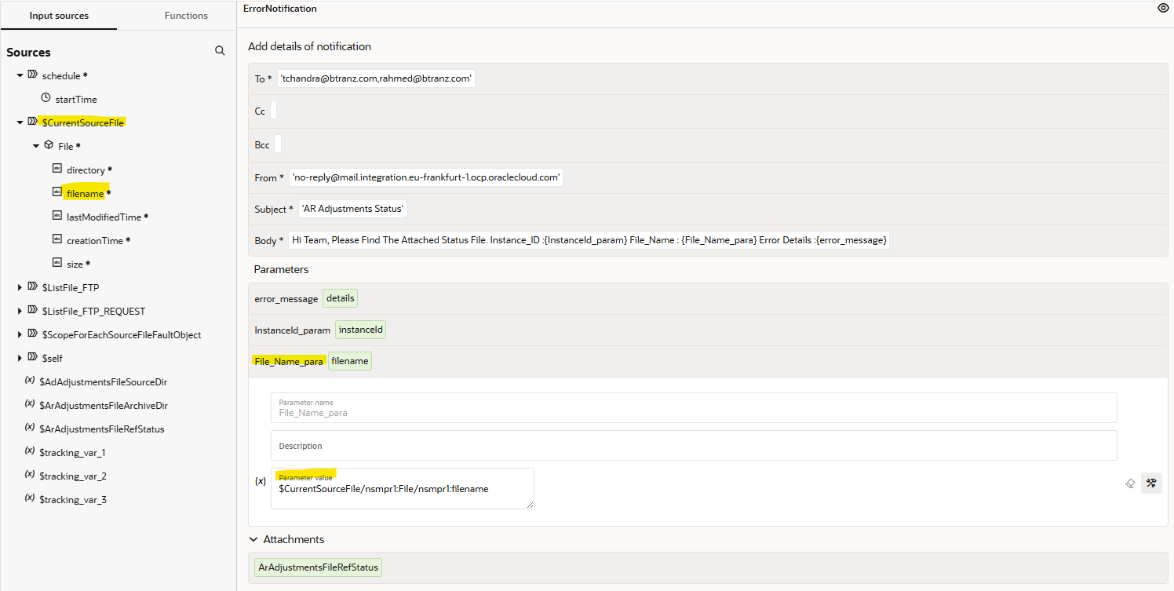

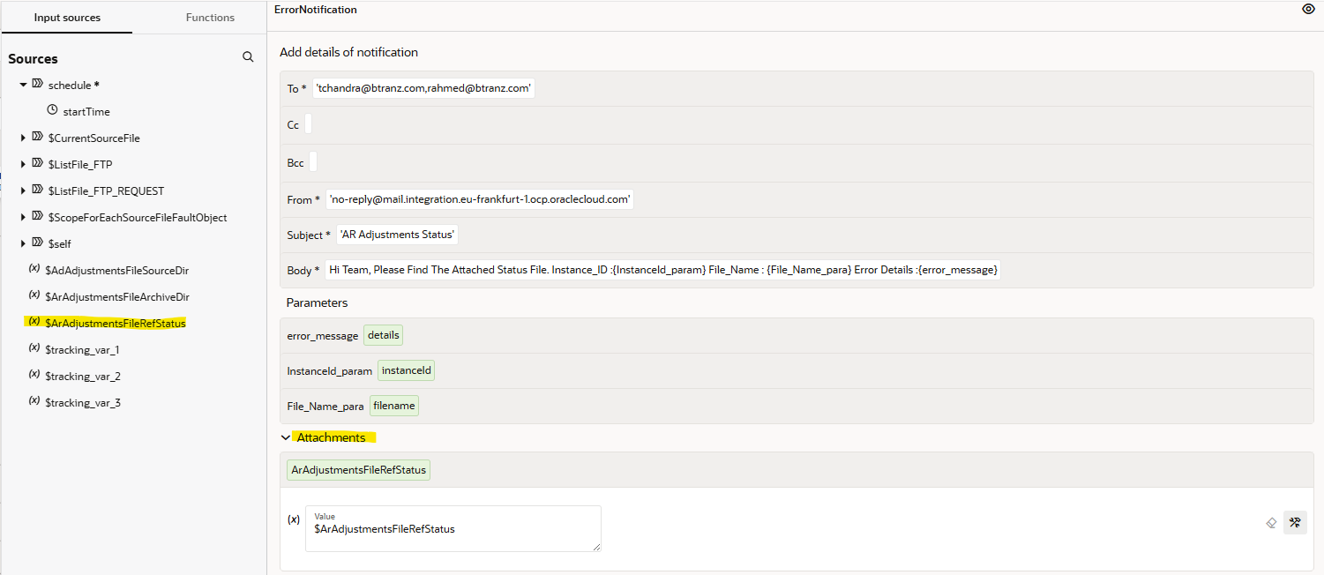

- Once out of the scope, create a Notification for the AR Adjustments created.
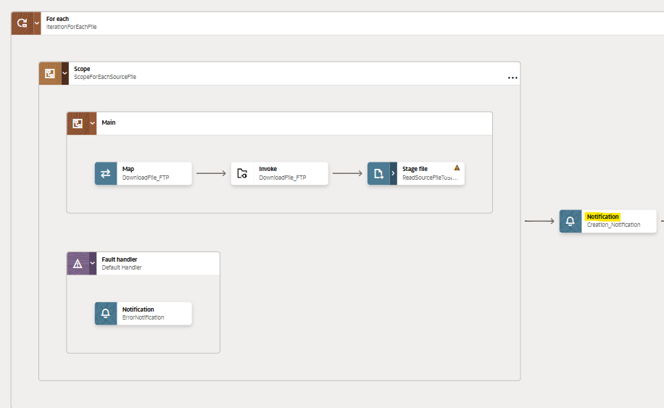

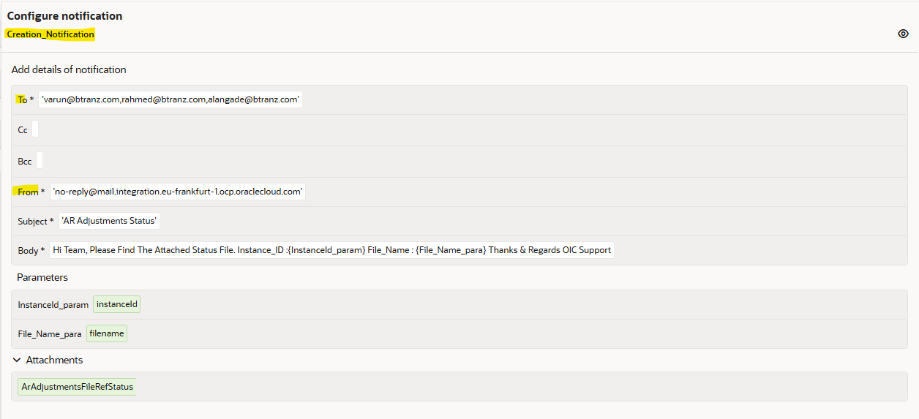

- Take the Parameters from the Input Sources as shown below.

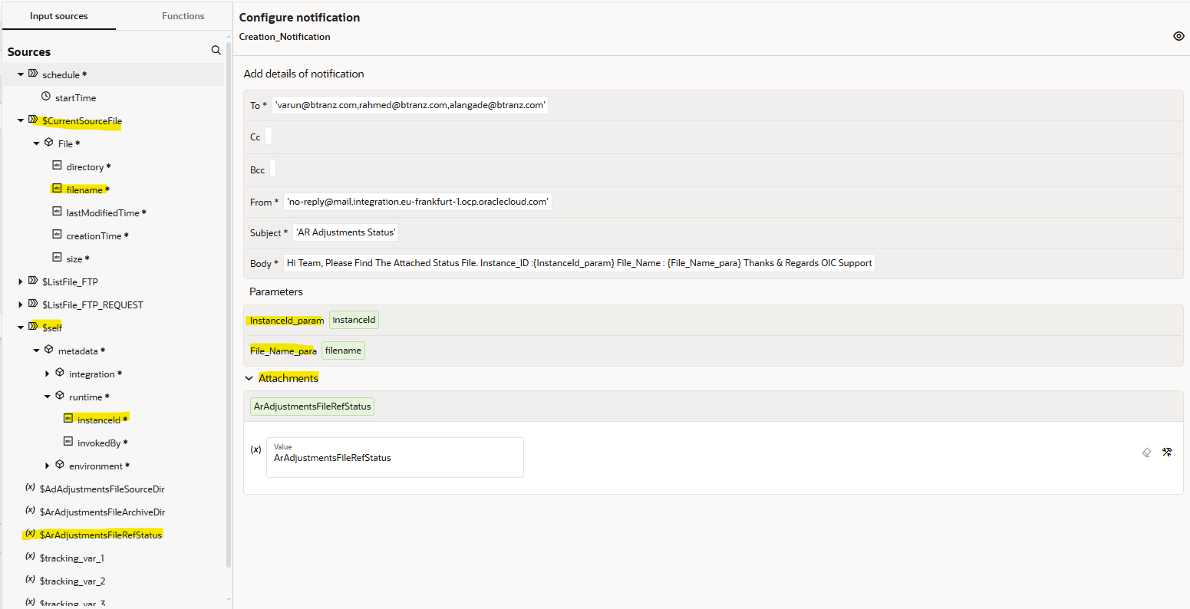

- Now use the FTP connection and use the ‘Move a file’ Operation to Archive the file.
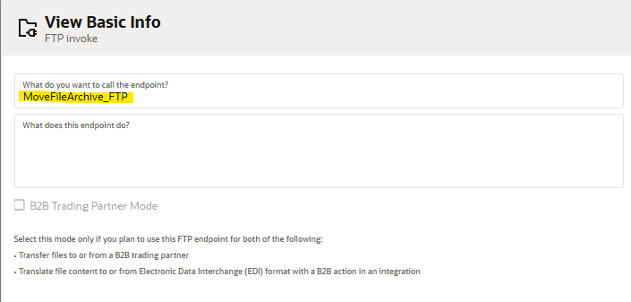

- Give paths as ‘/’ and filenames as ‘*’ as these will be passed from the Mapper.

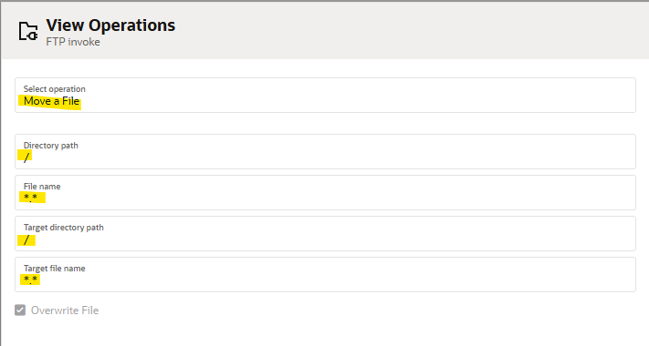

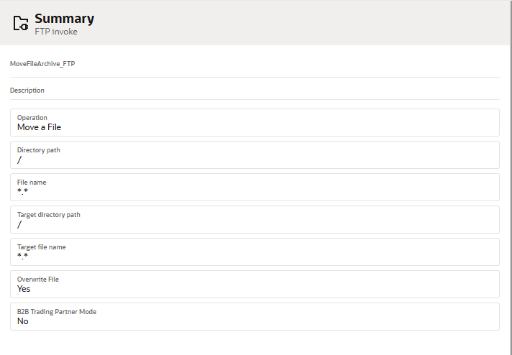
- A Mapper will be created for the FTP connection.
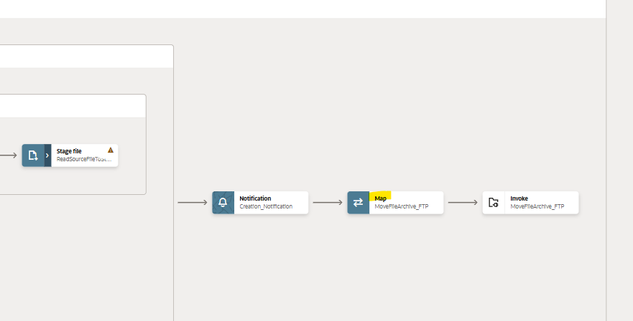

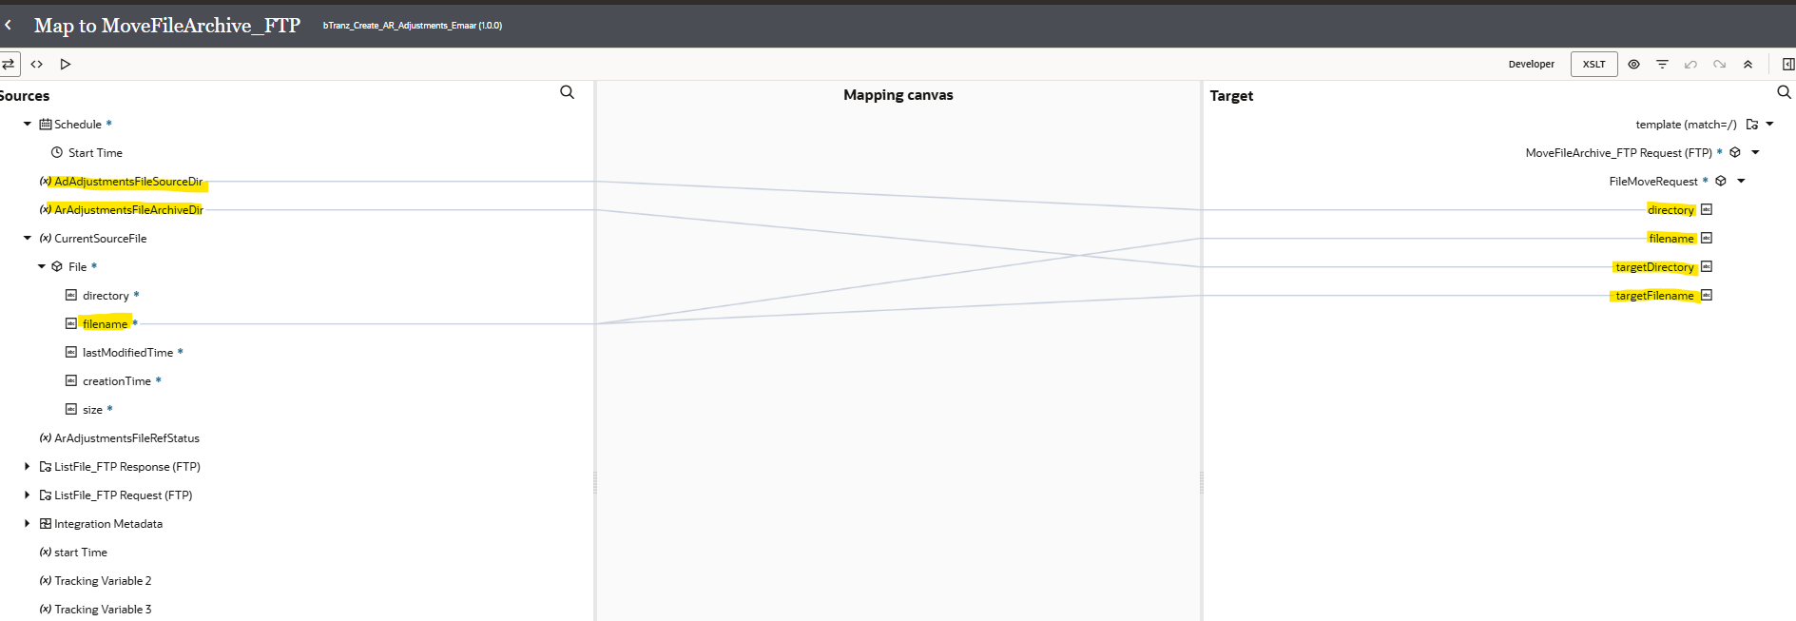

- In the mapper, map the Source Directory and Archive Directory variables to directory and target directory of the MoveFileArchive_FTP Request
- Take the Current Source Filename and map to filename and target file name of the MoveFileArchive_FTP Request as shown above

- For every integration we need to assign at least one tracking variable maximum we can assign up to three as it will be used when we are tracking the integration. Here, you can observe the error.
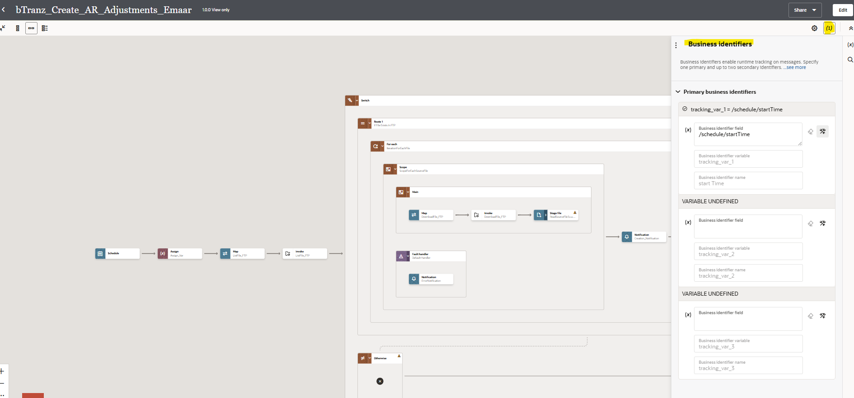

- Drag any variable from source to Tracking Field to mention it as Primary variable.
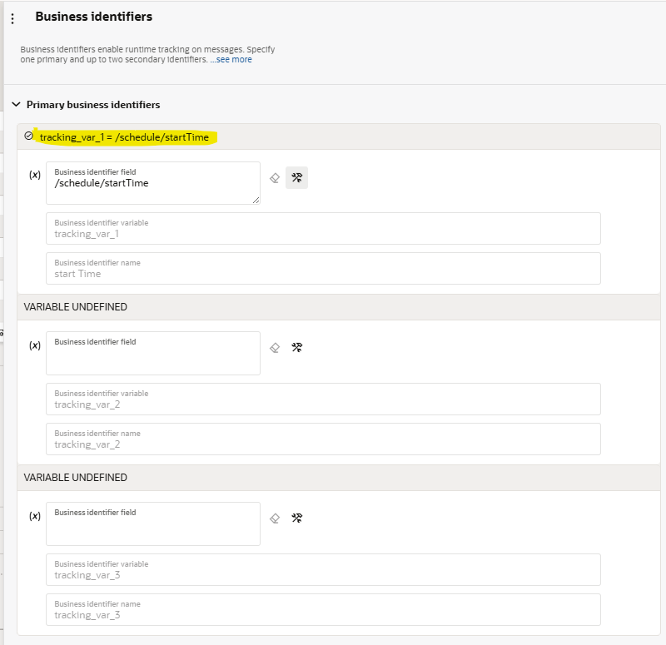
- Once you declare the tracking variable save and close the integration.
Running The Integration:

- Before running an integration we need to activate it initially it will be in draft state after successful creation it will be in configured state after activating it will be in active state.

- You can activate and schedule as per your requirement it will run or you can just activate directly.
- By checking include payload option it helps you to check the payload of each operation in tracking page.

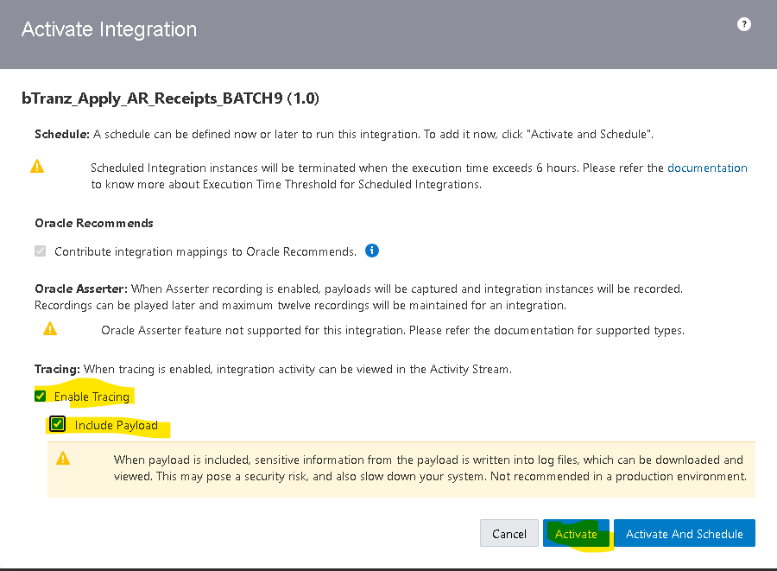
- By clicking on submit now option it will run the integration.
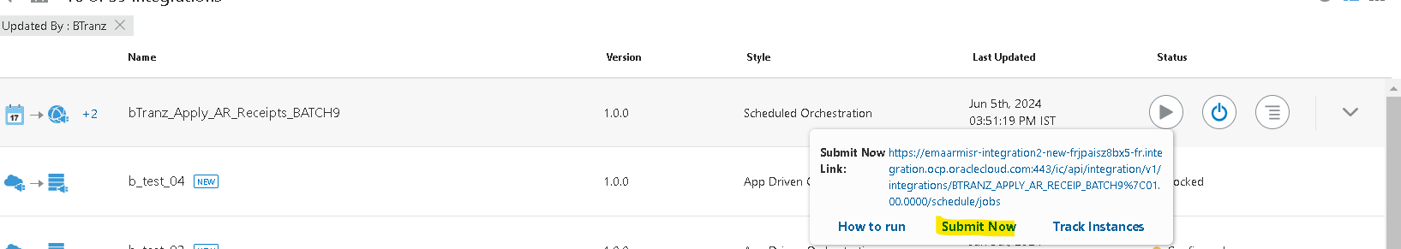
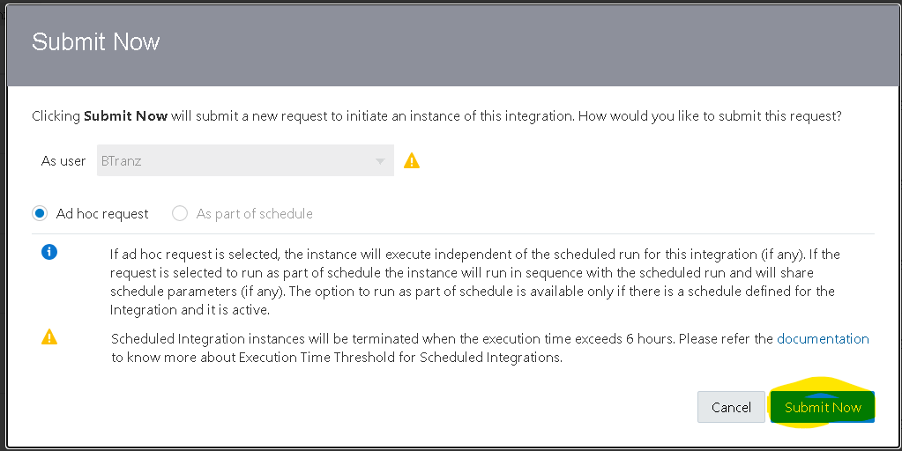
- You will get an InstanceId when you run the integration by clicking on that instance id you will be redirect to tracking page where you can check the status of that integration.
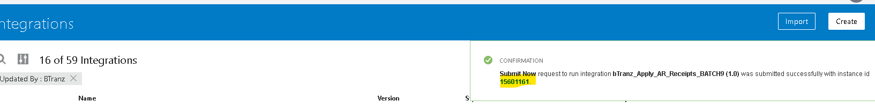

Tracking The Integration:

- To track the integration manually MonitoringIntegrationsTracking.

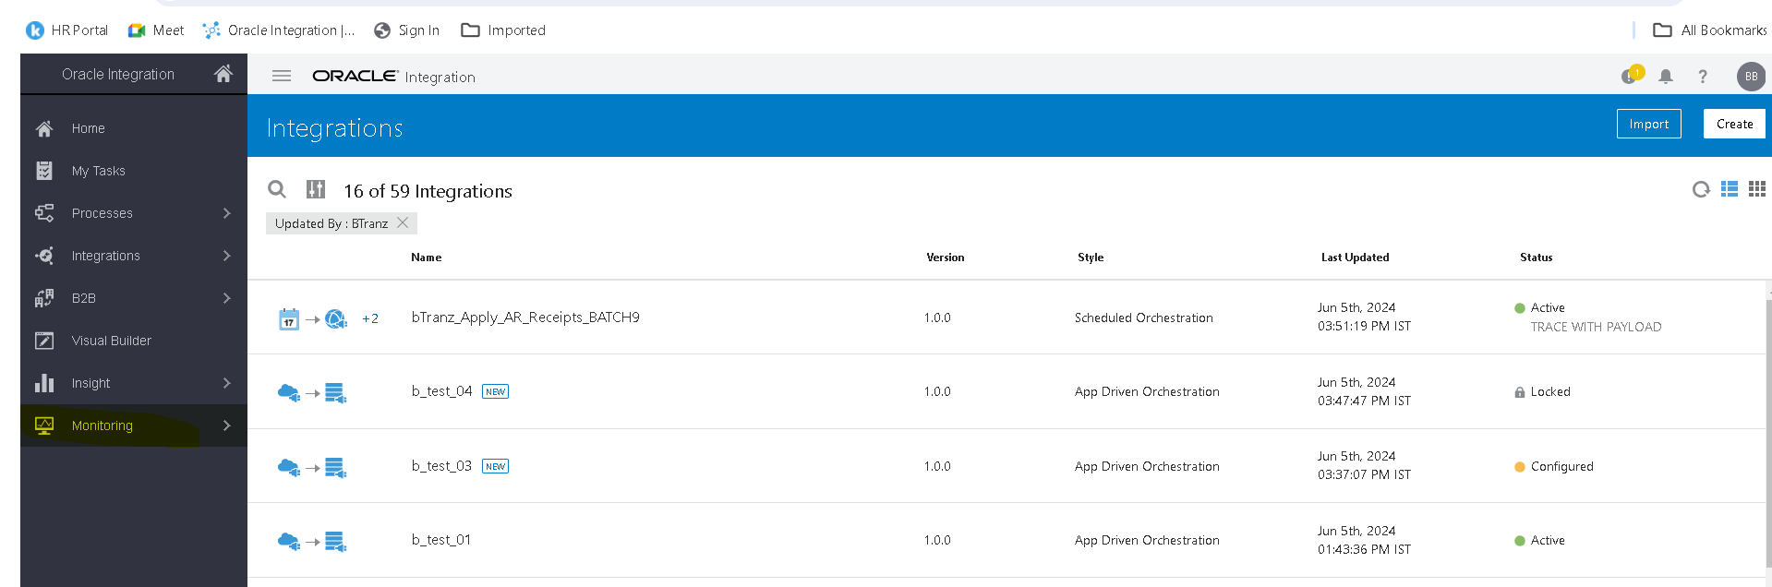
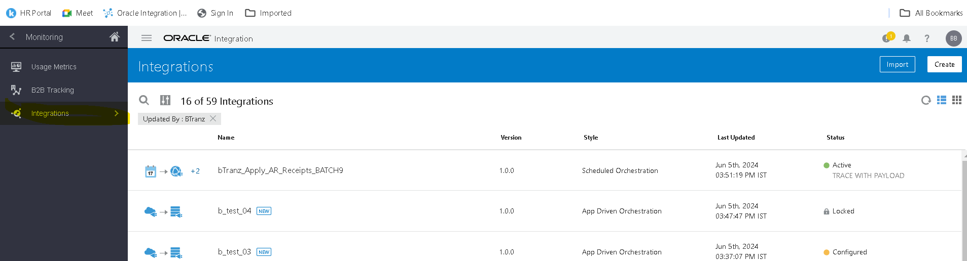

- Here you can observe the InstanceId and status of the integration (if you clicked on InstanceId while running the integration you will be redirected here)
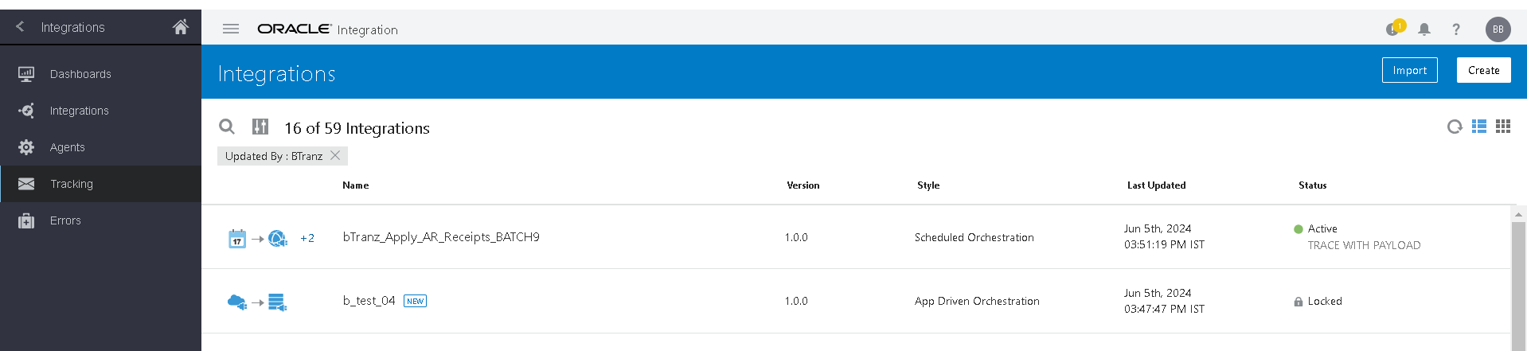
- By clicking on instance id in activity stream you can check the flow of the integration.
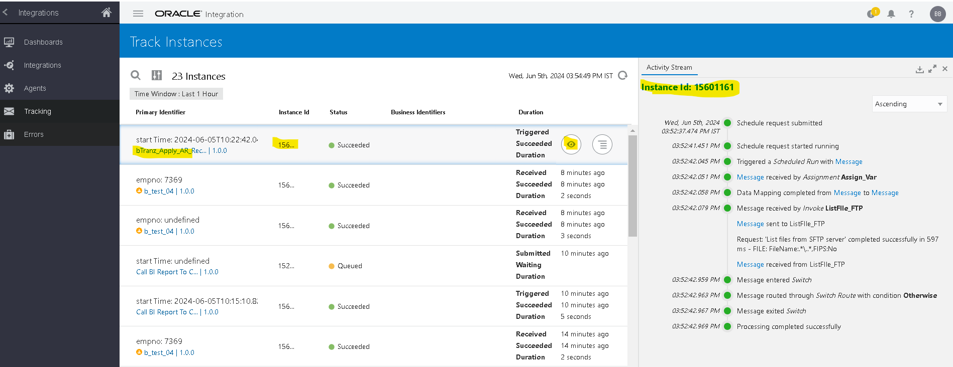

Open and Closed Issues for this Deliverable

Open Issues

ID | Issue | Resolution | Responsibility | Target Date | Impact Date

Closed Issues

ID | Issue | Resolution | Responsibility | Target Date | Impact Date

